

**REPORT ON**

***Remote Rope Deployment System***

By:

*Ethan Spall*

*Kathryn McGregor*

*Nic Gaskell*

*Jacob Kay*

**SUPPORTED BY**





**CONTENTS PAGE NO**

|  |  |  |  |
| --- | --- | --- | --- |
| 1 |  | Introduction |  |
|  | .1 | Background Information |  |
|  | .2 | Project Brief |  |
| 2 |  | Method and Project Plan |  |
|  | .1 | Problem Background |  |
|  | .2 | Research and Fact Finding |  |
|  | .3 | Selection of Solution |  |
|  | .4 | Project Management/Programme |  |
| 3 |  | Implementation of Project Programme |  |
|  | .1 | Results and Analysis of research |  |
|  | .2 | Selection of Solution |  |
| 4 |  | Problem Solution and Evaluation |  |
|  | .1 | Description and Evaluation of Solution |  |
|  | .2 | Testing of the solution |  |
|  | .3 | Future Developments and Implementations |  |
| 5 |  | Conclusions |  |
| 6 |  | Appendices |  |
|  | .1 | Company Profile |  |
|  | .2 | Our Team |  |
|  | .3 | Gantt Chart |  |
|  | .4 | Minutes? |  |
|  | .5 | Calculations/Tables/Figures/Photographs |  |
|  | .6 | Acknowledgements |  |
|  | .7 | References |  |
|  | .8 | Glossary |  |
|  | .9 | Company Visit |  |
|  | .10 | Summary of Key Communications |  |
|  | .11 | Justification of Proposed hardware solutions |  |
|  | .12 | EES Participation Evaluation |  |

**1 - Introduction**

**1.1 - Background Information**

The objective of The Engineering Education Scheme (EES) is to encourage Year 12, Lower 6th Form students, usually taking Mathematics at A level, to consider Science, Engineering and Technology as future career pathways through the application of theoretical learning. Working as a team, linked to a local company, on a six-month real scientific, engineering or technological problem, all key life skills are developed within the context of the world of work. Personal development realised through work related learning is at the core of this high quality educational enrichment scheme. The EES encourages companies to offer real live projects to a team of Year 12 students to work on over a 6-month period.

Nuclear Engineering Services Limited sponsored and mentored a team from Winstanley College, Greater Manchester to partake in the Engineering Education Scheme, an Engineering Development Trust (EDT) programme. Their company profile is enclosed as Appendix A.

**2.2 - Initial Brief**

The following brief was given to the team on the first Liverpool residential workshop day. Written by Peter Burn from NES.

*Background*

*In nuclear decommissioning it is often necessary to handle waste material remotely because the radiation levels are too high for people to work in.*

*Problem outline*

*A concrete silo was filled with waste in the early days of the nuclear industry in the UK (1950s-60s) . A scheme has been developed to retrieve the waste using a hydraulically operated bucket suspended from a wire rope winch. Access to the silo is through a rectangular aperture in the roof. To facilitate waste retrieval it will be necessary to position the rope anywhere within the aperture when viewed in plan.*

*To protect people from radiation the wire rope will operate within a shielded steel box situated directly over the aperture. The winch will be mounted on the roof of the shielding and the rope will pass through a small hole in the roof directly below the winch.*

*The rope positioning system shall:*

* *Place the minimum amount of equipment within the shielded box.*
* *Be a powered system capable of delivering the rope to 12 programmed positions.*
* *Not require any electrical components to be placed within the shielded room.*
* *Not compromise the shielding of the shielded box.*

*Desirable requirements:*

* *Little/No maintenance shall be required.*
* *Maintainable components should be replaceable without the need to enter the shielded box.*

*Deliverables*

* *3 concept schemes*
* *Concept review and down selection report*
* *Design drawings*
* *Working scale model (the drawings should be for the model)*

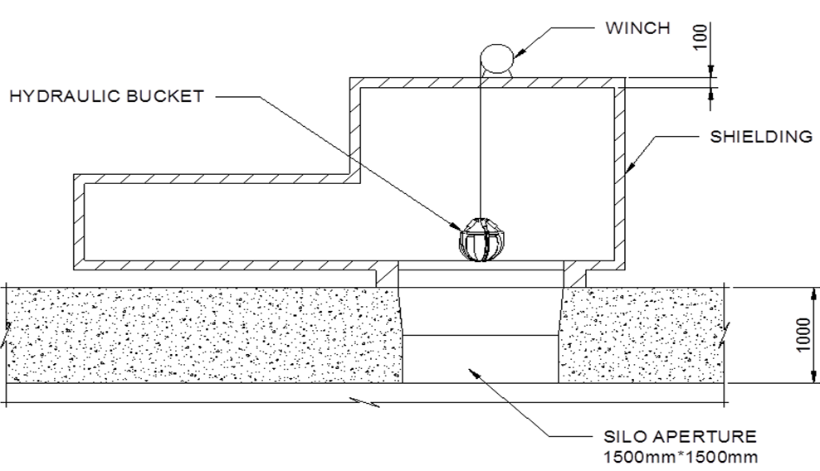

**2 - Method and Project Plan**

**2.1 - Project Background**

In the early years of the Nuclear age, Britain was far behind other countries such as USA and Russia in its nuclear capabilities. Therefore, Britain started researching into Nuclear Physics and eventually made Britain's first Nuclear reactor called Windscale (renamed Sellafield). To deal with the large amount of low level waste produced they built large concrete silos in the ground to store the waste. However these were poorly designed and have been deteriorating in condition for many years. There is no log of what is currently stored in any of the containers. It is thought that this can range from low level waste such as boots and lab coats but there is also thought to be a range of unknown items.

Due to the high risk associated with radiation levels found in the silos’, workers cannot be sent to remove the waste due to health/safety safety risks; NES were commissioned to make a controllable waste disposal machine to slowly remove the waste in the containers. Their current system involves lowing a hydraulic bucket into the silo through the aperture, to remove the waste stored in the silo. However they lack the ability to position the rope within the opening shaft (aperture). This is where the team was asked to step in to design and model/prototype a remote Rope positioning system that can be adapted to NES’ current solution; which includes a shielded box to stop any radioactivity from escaping so that it does not pose a risk to human health or environmental wellbeing.

The shielding is moved above the aperture in the silo and contains all the equipment used to remove and contain the waste. A bucket attached to a rope passes through a small hole in the roof of the shielded box and tools to remove waste are attached to it.

The actual silo is 8m x 8m and 16m deep, the aperture is only 1.5 x 1.5m and is in the centre of the silo roof. NES have specialised tools to reach further into the silo than the 1.5 x 1.5m aperture allows, but they require a rope positioning system to move the rope and tools into any position inside the aperture to aid reaching further into the silo. (This is where the EES team come in.).

The main restriction is the radiation emitted by the waste within the silo and the shielded box. The radiation emitted from within the silo will destroy any circuitry inside the shielded box by disrupting the lattice structures of the metal conductors within the circuitry. This radiation renders any electronics that are inside the shielded box inoperable. Therefore no electrical components can be placed inside the shielded box. NES have tested this, and this also means any system design must not compromise the shielding of the box. It also needs to be very durable and reliable as replacing parts inside the shielding would be extremely hard to do; as due to health and safety, a person can only work in there for a short time. Hence, NES must replace parts remotely.

**2.2 - Research and Fact Finding**

**2.2.1 - Initial Research and Ideas**

Initially there were three ideas proposed in order to reach a solution to the company's stated problem.

Idea 1:

The first idea included the use of 5 motors running in tandem with each other in order to reach several desired positions within the silo. This would work by placing 1 motor on each corner of the ‘shielded box’ above the silo, and the 5th motor centered above the silos’ aperture, to control the depth of the centre-piece. As the motors turn, a rope which would enter through holes in the corners of the shielded box, would be pulled. These ropes would be attached to a central plate which would hold the weight. This seemed like the optimal solution to the problem as it fitted the given company briefs’ specifications, and could have easily met the briefs desired ‘pre-programmed positions’ requested by NES, and maybe even exceed the expected number.7

Advantages:

* A very simple design that is very easy to prove and scale for larger use.
* All components inside of the shielded box are mechanical and so does not require any electrical components inside of the shielded box.
* The solution is relatively easy to replace and repair if there is a failure.
* It allows for a near infinite number of positions inside of the shielded box

Disadvantages:

* If a rope breaks it can lead to a long time to repair
* It can be a very slow way to control the rope position
* It will require a complex control system to work.

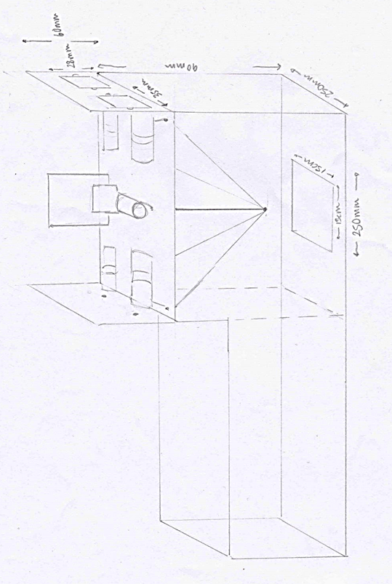

Idea 2:

The next proposed solution was to use a bar linkage mechanism to manipulate the rope on the wire into 12 pre-programmed positions. This would work like a Spirograph or Harmonograph with the mechanism inside the shielded box and a winch on the outside to move the bars into position.

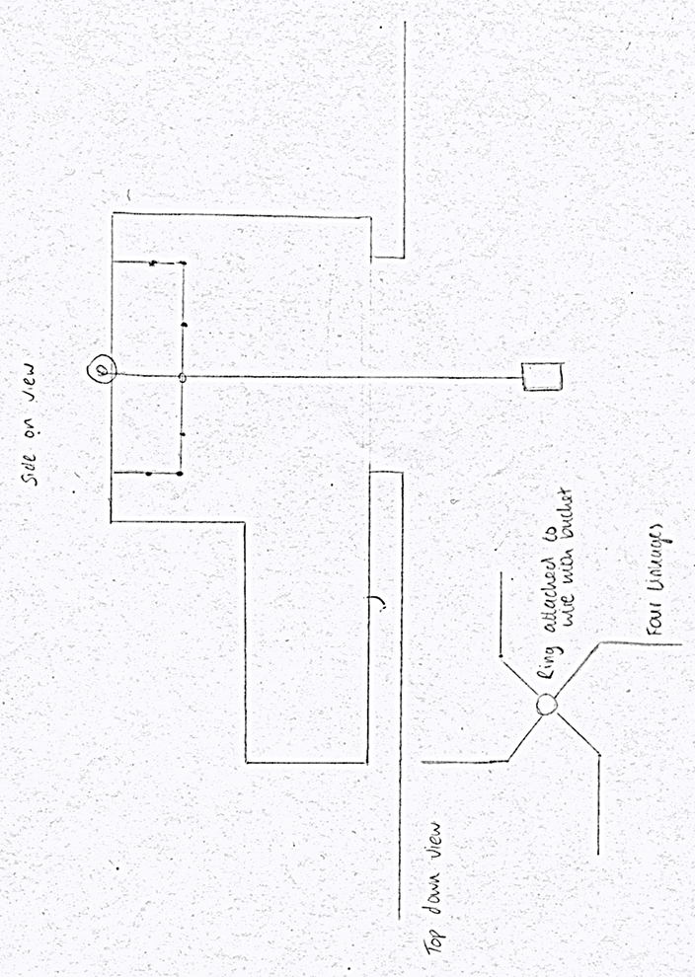

Advantages:

* Completely mechanical, and so is not subject to electrical malfunctions due to the radioactivity.
* It can however be automated from outside the shielded box to avoid this and still be a computer controlled device.
* Has the ability to achieve 12 pre-programmed positions with the right arm/links configuration.

Disadvantages:

However there are limitations to this idea

* It would be a large device to install into the shielded box and therefore be expensive and difficult to decontaminate or dispose of if it needed repairing
* To achieve 12 pre-programmed positions that adequately covered the area inside the container and reached the corners, would involve linkages that once unfolded to a maximum length would be longer than the dimensions of the container.
* This problem would require too much technical ability that we did not have in this subject or that was attainable in the time frame we had.

Idea 3:

The third proposed solution involved a hydraulic arm that was made up of two movable parts, a vertical arm which the main rope went through and a horizontal beam that was attached to the bottom of the vertical arm through a gearing system and a universal joint. The rope passes through the horizontal part of the arm, and out the end. This arm can then be rotated about the vertical arm, the horizontal arm can also be raised up and down around the joint with hydraulics .

Advantages:

* This combination allows for any position inside the shielded box by raising and lowering the end of the horizontal and rotating it, the end (and hence the rope) can reach any position within a circle around the rope entry position
* This solution allows any position to be reached inside the aperture, and meets the requirement of 12 positions.
* This solution has no electrical components inside the shielding, therefore doesn’t compromise the shielding.

Disadvantages:

* However this solution doesn’t place the minimum amount of equipment inside the shielded box.
* It includes a complicated gear mechanism with a universal joint supporting the weight of the horizontal beam. This would be very hard to model, and when scaled up it would be prone to a lot of failures and hence create a lot of extra waste for NES to deal with.
* It requires a very control systems, that if failed could cause a large amount of damage to the inside of the shielded box and lead to it being ruptured.

**2.3 - Selection of Solution**

The final solution decided by the group, was the 5 rope system as it was the most practical to demonstrate and was seen by the team of engineers as the most likely to be successful in fulfilling the company’s assigned brief. In order to decide upon a final solution to the problem, multiple factors needed to be taken into consideration, such as: the cost of the solution, real world application, feasibility, and the groups’ abilities. After weighing up the Advantages/Disadvantages of the alternate solutions mentioned in the above section, it was decided not to pursue the other ideas due to the lack of resources available to the team, at this level, such as, a hydraulic arm which could work as part of the positioning system solution. But is not feasible to do, given the small allocated time scale , and the lack of resources available for use at Winstanley College.

An alternative solution was also deemed not worthy due to high maintenance that would be required and the lack of customizability available for the most direct path and the other system was found to be closer to the brief. With these factors in mind it was then decided as a team that the 5 RRPS (Remote Rope Positioning System) would work the best and would fit the company's brief more.

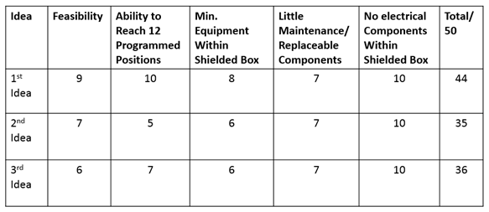

**Justification & Testing of proposed solution**

After consulting with the engineers at a meeting, a joint conclusion was reached with their professional input. It was decided that the first solution, the five motor solution, was the best proposal. This solution was preferred because it was simple, could be modelled, and met and exceeded the requirements of the brief.

To test and ensure our solution was viable, a simple model was constructed; codenamed ‘Kath’s Box’. This was a metal box with a hole in each corner, through which string entered. The four strings terminated at a piece of modelling clay that simulated the central plate in the solution. Testing the solution involved the four of us holding the box up, and pulling on ropes from above at different times. The original intention was to position the motors on top of the container to move the ropes from above, however this model showed that the weight would be pulled at an angle. This would lead to inaccuracy in its position. After adapting the concept and re-modelling it by pulling the ropes from the side, the weight was pulled straight and so brought the conclusion that the motors should be mounted on the side of the box.

This proved we can get to any position inside the shielded box and our solution was valid and viable. After providing the evidence to the engineers, permission was granted to model that specific solution. This allowed the team to make technical drawings, and CAD designs of the model. This then allowed further development of the idea, and then for the team to send purchasing requests to NES for the components necessary.

**Model**

The majority of the proposed solution was mechanical, so the mechanical aspects were split up into three main categories: the model, the motors, and the spindles/rope related aspects.

There was a need for a scale model of the problem, which allows visualisation of the criteria set out by the company. The dimensions of the shielded box were set to 300mm by 300mm x 150mm (WxLxH), and the aperture would be 150mm x 150mm centered in the shielded box.

The criteria for the model were:

* sturdiness
* cost
* ease of assembly.

The choice of material for the shielded box was driven by the need to see the solution working, so it could be demonstrated easily. Due to its cost and transparency 5mm clear perspex was used to model the shielded box. The base and ‘legs’ of the model were made out of MDF (Medium-Density-Fibreboard) , because it was cheap, sturdy, and easy to assemble. The MDF base support legs hold up the MDF used as the base.

It was decided to use 5mm thick clear perspex to model the shielded box that sits on top of the silo as it is:

* strong,
* relatively cheap,
* it allows the solution to be monitored from the outside

In order to support the weight of the motors and circuitry, a sturdier material was needed to make the base and represent the aperture and silo. Various types of wood were considered, but were found to be too expensive for the budget. We settled on using MDF for the base as it was cheap, readily available, easy to cut to size and strong.

The sides of the base were also made from MDF for the same reasons. For the stands holding the motors at the corners of the box, we decided to use cut blocks of pine wood, as it’s strong enough to support the motors, easy to drill through, and relatively light, as to not place too much weight/strain on the base of the model. Perspex was used to create the motor holders/brackets. This was because perspex can be easily molded into the desired shape of an “L” bracket by using heat, which was done at Liverpool University.

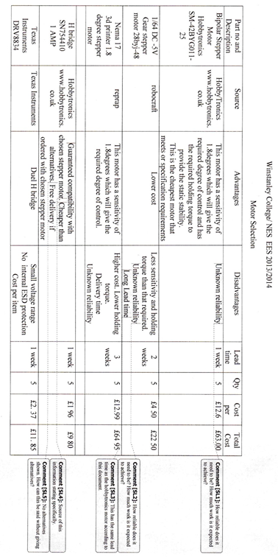

**Jacobs’ maths**

**The force required for the motors to use, and which type of motor**

**Techniques for Winding Wire**

As the motors pulled the weight into different positions, the wire needed to keep tension and wind around a device. Initially using a threaded screw seemed the best solution, as the wire would not layer over itself, which could have an effect on how much the motors needed to turn to move the weight to a specified point. However, this effect was negligible in practice. Also, the screw length and the depth of the grooves would need to be calculated, which wouldn’t have been necessary for the accuracy of the model. The concluding solution was to use an unthreaded spool, and let the wire overlap. This could be made precisely by the engineers in Liverpool and effectively wind the wire.

**Selection of Wire**

To select which wire was best to use, research into materials such as Paracord, electrical wire, Dacron, string, yarn, thread, guitar strings and fishing wire was undertaken. The wire needed to be thin, flexible, and not hold its shape when unravelled. It also needed to be strong, and hold tension. Research into different gauge nylon guitar strings revealed that although strong and easily obtainable, all of them held their shape and so were not suitable for winding round the rope drum. After research through testing the materials using a pulley and some weights, as pictured below, we found that electrical wire was the best option as it was thin enough to be flexible but strong enough to provide tension and support the weights.

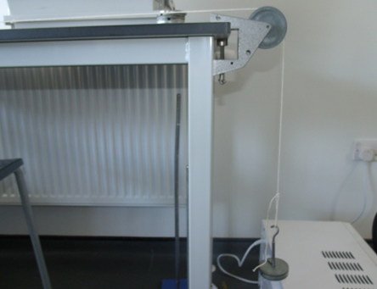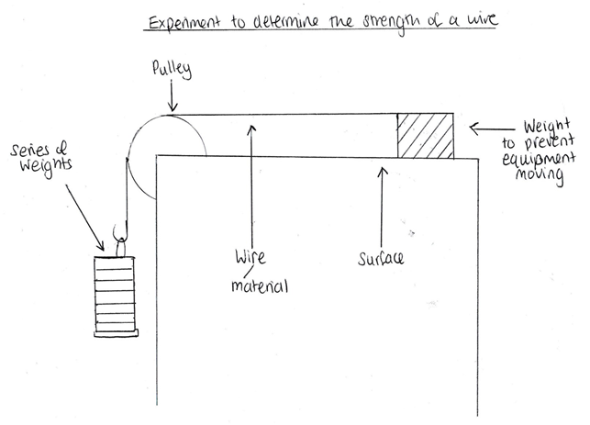

**Attaching the Spool to the Motor**

To keep the spool attached to the motor it needed to be glued in place, be a push fit or be kept in place using a grub screw.

Glue would hold the spool in place however if under stress it were to break, it would be hard to repair without destroying the motor, barrel or both. Therefore glue is not going to be used to keep the barrel in place.

A push fit of the spool to the motor axle would work only under low torque as it relies on the friction of the spool to axle. If this were to slip when in operation it would cause the central weight’s position to be inaccurate.

It was decided that a grub screw would be placed through the spool to hold it to the axle of the motor. This reduces the possibility of it slipping. It also makes it easy to repair if it needed replacing.

**Communication between Arduinos**

Research was conducted on inter-Arduino communication by sourcing the Information from the Arduino site. The best method found was to use the wire library as this was similar to other methods previously used by members in the group and was simple. However once in Liverpool it was best to change to SoftwareSerial as the correct order of communication could not be achieved by running two Arduinos off a central ‘master’ using the wire library. Only one message could be sent at a time. Changing to SoftwareSerial enabled effective communication between the three Arduinos so that messages were sent from the central Arduino to the others at the same time.

**Programming**

To be able to program the Arduinos, basic coding skills in this area were needed. To gain experience the Arduino website was used to reference key terms, syntax and example codes. Other websites and forums were used to explore multiple ways of solving similar problems which would contribute to the final code. Methods such as Pseudocode helped to model what the code needed to achieve in what order, and flow charts showed which message was sent by which Arduino and when it was received. Pictured below is an example of this planning where a flow chart of the system is depicted in a cycle. The coordinate system used is based on the positions on the motors around the box with (0,0) at motor 4 in the bottom left corner.

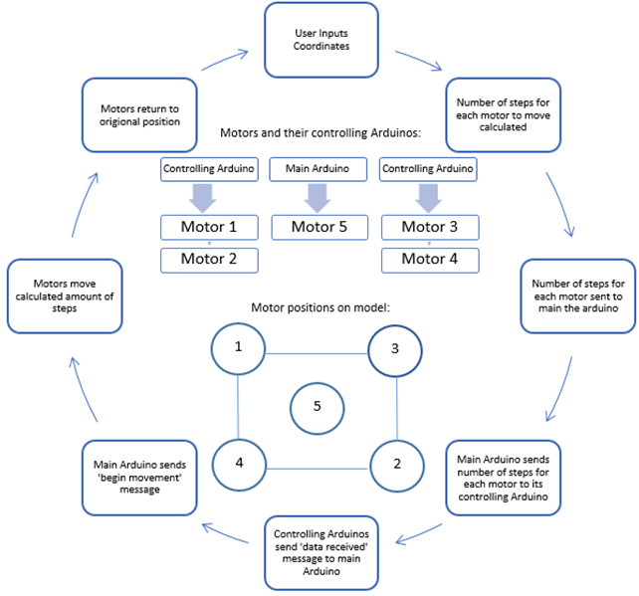

**2.2.4 - Selecting a control system for the RPS**

For the RRPS to work it would require a complex control system with the ability to be programmed and have a basic input and output system. For this we had 3 main choices: they were the Arduino, The Raspberry Pi and a PLC unit/s. A PLC is a programmable logic controller that uses logic to control the inputs and outputs. A PLC is often used in industry for industrial control units however it is because of this fact that they are very expensive and require specialist training to program. This caused the team to rule out the use of a PLC very quickly due to cost being outside of our budget. This narrowed down our choices between Arduino and the Raspberry Pi. When we started doing research on the Raspberry Pi it was found that the number of input and outputs were limited and the output power of each pin was also lower than required. Also no one in the team has had any experience in programming the RPI in any language that can be used. This would put the project at a disadvantage if there were a problem with programming it as there wouldn't be any one else in the team who would be able to give real time feedback and possible solution to help the other member of the team. As the project requires the ability to control these, there were no pre built libraries to help the programmers to control the stepper motors so it would require the programmers to build their own libraries from scratch which would delay the programming of the controllers.

With these disadvantages the team decided to use the Arduino micro controller for the project

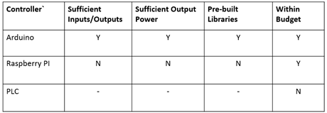

**Circuit design**

The solution had a hefty electrical side to it, a control system composing of arduino chips and h-bridges to drive the motors. Since there was a need to drive 5 motors, the circuit had to comprise of 3 arduinos and 5 h-bridges. It was decided that a proper electrical schematic had to be designed to reduce the chance of making a mistake. The circuit design required a lot of research into programs that can be used to make schematics, as well as some components, Such as filtering capacitors for power rails.

Most of the circuit design was adapted from open source designs for the ATMEGA328P-PU chip that was used. The main changes were having three Arduino chips that had to be isolated, the addition of five h-bridges, and three separate and isolated power rails. The layout of the circuit was key, and it was quickly decided to have the leftmost Arduino power motors 1 and 2 (calling it Arduino 12), the middle powering motor 5 (Arduino 5), and the rightmost powering motors 3 and 4 (Arduino 34). This simplified the design. Each Arduino required its own 5V supply that came from a VRM (voltage regulator module) which took an input of 9V-12V and outputted a stable 5V. This meant there had to be an input power rail of 9V-12V.

The H-bridges each took 4 power inputs, one that powered the logic gates and two that enabled each half of it, and one that powered the outputs. Since both halves of the h-bridges needed to be enabled, and the logic gates needed to be powered, a voltage had to be found that would suffice for both. After consulting the data sheet on the h-bridges it was found 5V would be necessary, so a separate 5V power rail had to be provided. While it could have been drawn directly from the Arduino’s power supply, since the H-bridges would be outputting an oscillating signal (and the logic gates would be turned on and off frequently) they would return a lot of unwanted noise on the ground rail which could interfere with the operation of the arduinos; hence the separate power rail. Each H-bridge required a power supply for the motor, and since each motor required 12V at up to a current of 0.3 amperes each (1.2A in total) there was a need for the third and final separate power rail. This power rail only powered the motors, and it has a capacitor across it and a ground rail to reduce the noise that is created due to the operation of the H-bridges. Each H-bridge required 4 connections to it’s respective Arduino, so these were optimised to require the least amount of wiring on the actual circuit and to keep each wire roughly the same length.

The electronics for each Arduino comprised of a few capacitors, a 16MHz crystal, a few resistors, two leds, and a VRM. The main circuitry was adapted from an open source design for a ‘breadboard arduino’, and changed to fit the form factor of our stripboard and to suit our requirements. The full circuit diagram, and the source diagram that it’s based on are included in the appendix. The capacitors were necessary to filter out noise on the power rail, and crystals.

To communicate between the computer and the Arduino chips, an FTDI header had to be put on the board for each Arduino. It is a 5 pin header that is wired up to the RX and TX pins of the Arduino and to the reset pin (through a decoupling capacitor), and the ground was connected to the ground of the arduino power circuitry to ensure both the FTDI chip and Arduino had the same reference point. The FTDI chip is plugged onto the FTDI header and connected to the computer with a mini USB cable; this allows for serial communication to and from the Arduino and the ability to upload ‘sketches’ (programs/software) to the Arduino.

It was decided that the circuit would be made on stripboard as this allowed more flexibility and stability than using breadboards; this is because breadboards are quite delicate and there is the constant risk of breaking the circuit and having to rebuild it. Stripboard allows for a more permanent solution, and looks more professional. To make the soldering of the many components easier, a visual diagram of the circuit laid out on a stripboard was produced. This also made clear which tracks needed to be cut, and where, preventing many errors and shorts.

**2.3 - Method and Project Plan**

**3 - Implementation of Project Programme**

**3.1 - Results and Analysis**

From the initial testing in the prototyping phase the chosen solution looked promising. However it was only after the model was made and tested that the solution showed the most promising results. Before the circuit board was finished, the stepper motors and basic frame of the model was already built. This allowed half of the team to check that they could move the plate around the box by hand, turning the motors together so that they could do a much more refined simulation of the design. This was done to still allow the team to make slight alterations to the design without making massive changes to the design.

Once the circuit board was finished the team were able to connect the motors to the board and upload the programs to test that the use of all 4 motors working together will be able to move the central rope anywhere around the aperture to the desired requirements.

**4 - Problem Solution and Evaluation**

**4.1 - Description and Evaluation of Solution**

From the solution that was designed it clearly shows that it is a viable possibility for NES to use as part of their SEP machine. Our model shows a proof of concept of the idea and goes beyond the given brief in its ability to go an infinite number of positions instead of the give 12. It also provides a reliable method of moving objects around the inside of the silo without endangering lives.

**4.2 - Testing of the Solution**

Once all of the hardware was built, it was then necessary to test the hardware and software to ensure they would work in unison.

To test the mechanical aspects of the solution, i.e. the motors and spindles, it was necessary to build a small test circuit. A simple breadboard circuit consisting of two H-bridges (motor drivers), and an Arduino Uno was built. Two motors could be tested at a time. The Arduino Uno was programmed with a simple program that would turn motor 1 a full revolution clockwise, and motor 2 a full revolution anticlockwise. This would test the ability of one Arduino driving two motors through two H-bridges. Testing all 5 motors proved that a single Arduino can run two motors in opposite corners with no delay confirming our proposed solution was viable. It also confirmed all five motors were working and could support a mass of 100g, which was a requirement for the model set by the engineers.

Before making the circuit, a circuit diagram and electrical schematic was designed. It was then peer approved by the entire group to remove any possible issues. After that initial test, the circuit was soldered together on a breadboard. To test it initially, a multimeter was used in continuity testing mode to check for any short circuits that could damage any of the arduino ATMEGA328P-PU chips, or the H-bridges. After this, power was connected up to the board without any chips in place and a multimeter in voltmeter mode was used to check the voltages were correct at each pin. This ensured that no chips would be damaged after they were put in. Finally, after ensuring that the chips would be safe from any shocks/ static discharges or short circuits they were inserted into the IC holders and the board was powered. After powering the board, each Arduino had a simple program uploaded onto them, that would flash the red LED connected to digital pin 13 ensuring the Arduino was in working order. A program was then loaded that would just turn the motors connected to the Arduino to ensure that the connections between the Arduino and H-bridge were good. This also tested the motors again as it made one go through one revolution clockwise and the other through one revolution anticlockwise. The final part of the circuit to test was the rx and tx lines that went from arduino 5 to Arduinos 12 and 34 and communicated the number of steps from arduino 5 to 12 and 34. This was done with a simple program loaded onto Arduino 5 that sent signals on the serial lines to Arduino 12 and 34 which each had a program that would flash the LED if it received a signal on the serial line. All of this testing eventually proved the circuit board was fit for purpose and that each Arduino could have their final software uploaded for testing.

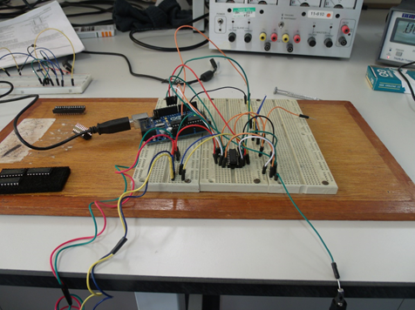

Whilst developing the hardware in Liverpool University the software was initially planned and written. Originally it was written for a Linux based system however later it was found out that the software would work better on a Windows system. This was discovered while testing the communication between the computer and the circuit. This required a complete rewrite of the computer side of the software. Initially, after writing the software it was tested with hypothetical values by hand to find that the correct outputs were given and to ensure the computer software would send the correct signals to the circuit board and the circuit board would respond correctly (also known as ‘dry testing’) . The dry testing appeared to show the software would work fine. However, while testing the finished circuit and software in unison, there were problems found with handshaking and communicating between the computer software and the main Arduino. This resulted in a lot of debugging and reprogramming of both the computer software and the software on the Arduinos. Eventually the software was finished and there was complete communication between the computer software, and the Arduinos, and in between the Arduinos.

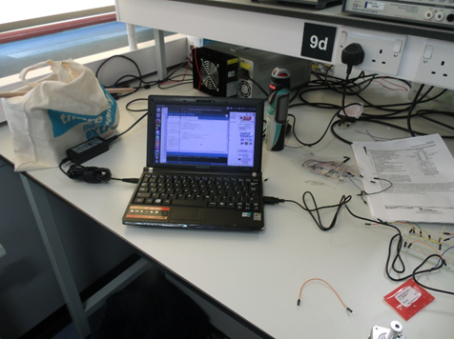

**4.3 - Future Developments and Implementation**

For NES to adapt the proposed solution to their current SEP (Silo Emptying Plant) would be possible however it would require a slight redesign of their current solution only due to the fact that the group did not take into consideration additional items that NES use for their solution such as Robotic arms and other equipment inside the shielded box.

The proposed solution used stepper motors to move the ropes and the bucket around. Currently , there are no stepper motors with sufficient power/torque output or accuracy (in terms of steps per revolution) that would be required at NES. If they were to use them it would be extremely costly to build their own. It is therefore recommended that NES use conventional DC motors and build custom gearing system that can finely control the output and hence the position of the main rope. This would also have a feedback system that the solution proposed lacks, allowing the operator to know for certain the rope is in the correct place.

For the control system it would be recommended that NES uses a series of PLCs (Programmable Logic Controllers). These are industrial controllers for very specific purposes and allows easier programming of the controllers in an industrial environment and are universal for control. NES would require a few PLCS that are all connected together so that they can control all of the motors in tandem and it also allows for a very safe, controlled environment.

For the actual ropes used in the system, NES may need to use thick steel anti-twist cable to move the plate around in the container. This is so that the cable can withstand a large amount of strain and stress over a large amount of time without breaking. It also reduces risk of any breakages due to the high strength held by them.

A feedback system for the length/position of the ropes. A proposed solution to provide this feedback could be to use a laser system, which could be attached to the motor end of the rope, and be aimed at the centrepiece of the system. Providing a continuous data log of the ropes length, and hence, its position.

**5 - Conclusions**

Over the course of the EES project the team has had to learn many skills for the successful completion of the project; Whether this be learning how to program or circuit design to problem solving and leadership skills. The team has also gained a larger skill set in the engineering field and have learnt new things that without the EES Scheme would not be known.

The demonstration model succeeded in being a proof of concept; Showing that a RPS of this type would work as a possible solution for NES. However, If the group had more time to work on the project, possible improvements could include; making a custom circuit board; adding better wire to the box, developing the programs by providing them with a GUI, including a positive feed back system and more precise electronic equipment.

**6 - Appendices**

**6.1 - Company Profile**

Nuclear Engineering Services (NES) specialise in the design, manufacture, assembly, test, installation and commissioning of bespoke solutions for the nuclear decommissioning, defence, and nuclear new build markets.

NES has over 60 years nuclear experience, with company origins dating back to John Thompson and the supply of the first nuclear reactor housing to Dounreay. NES has supplied an extensive range of equipment and solutions to most UK nuclear power stations, including fuel route, remote handling, inspection equipment, encapsulation, waste handling solutions, gloveboxes, shielded containments, and reprocessing equipment.

Engineering department capabilities include concept through to detail design, design substantiation, safety case support, peer reviews and feasibility studies, site surveys and reports. Engineering resources are split across 2 NES sites, Wolverhampton – Head office, and Risley – Centre of Engineering Excellence.

Manufacturing, assembly and test facilities, are located at both Wolverhampton, and NES’ new North West Division in Beckermet, the closet facility of its type to the Sellafield site. Both facilities contain high bay test towers up to 30m, and 6m deep test pit facilities.

NES manage projects through Integrated Project Teams (IPT) engaged in engineering, manufacturing, assembly and testing, driving a disciplined and structured approach to planning and project management, the key to successful contract performance.

NES also retain Ultra High Pressure (UHP) waterjet technology capabilities including UHP cleaning and decontamination units that can be fixed to a manipulator for remote access in hazardous environments.

**6.2 - Our team**

**Ethan Spall - Team Leader/ Lead programmer**

**Jacob Kay - Electronics Engineer**

**Kathryn McGregor - Arduino Programmer**

**Nic Gaskell - Model Engineer**

**6.3 - Gantt chart**

For the duration of the project

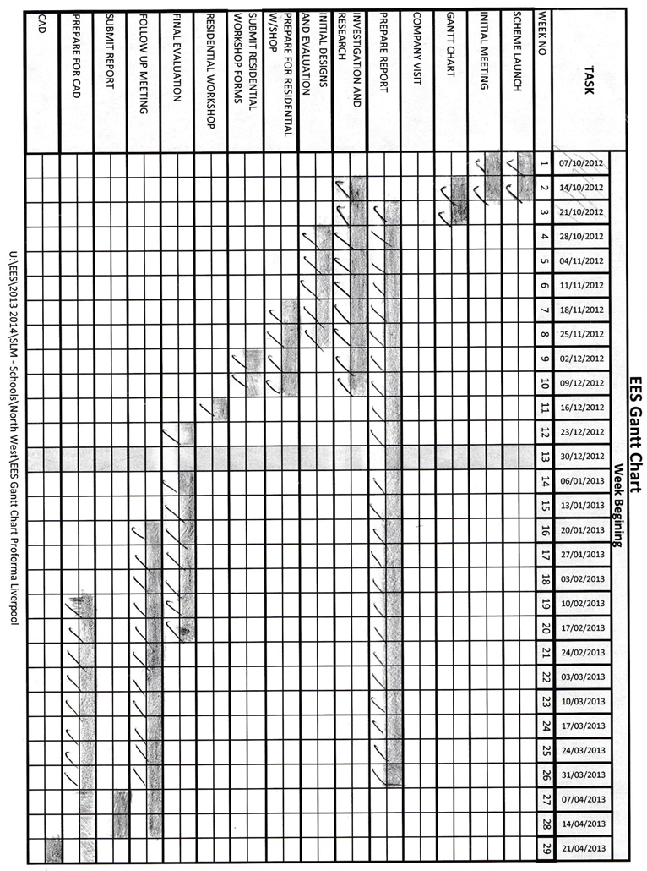

**6.4 - Minutes of meetings**

Instead of having one person take notes for the entire meetings, all of the meetings with the engineers were recorded so that the group can look back at the meetings and all that was said and it also allowed the group to have clarification on the decisions made. Therefore the minutes of the meetings are not available to put on the report.

**6.5 - Calculations and Figures**

**6.6 - Acknowledgements**

We wish to extend our appreciation and thanks to the following, without whom we would not have had this experience.

* The Engineering Development Trust
* The Engineering Education Scheme
* Nuclear Engineering Services (NES), for their sponsorship
* Project Managers from NES, Mr Sanjay Lad and Peter Burn
* University of Liverpool, and their staff for the extensive use of their facilities
* Winstanley College, especially Mr Geoff Woodward

**6.7 - References**

For the project the following resources of information were used:

<http://arduino.cc/>

Stepper motors:

<http://robocraft.ru/files/datasheet/28BYJ-48.pdf>

<http://arduino-info.wikispaces.com/SmallSteppers>

<http://www.hobbytronics.co.uk/motor-control/stepper-motors/stepper-motor>

<http://www.hobbytronics.co.uk/tutorials-code/arduino-tutorials/stepper-motor-sn754410>

<http://arduino.cc/en/uploads/Tutorial/Unipolar_sch.jpeg>

<http://arduino.cc/en/uploads/Tutorial/Unipolar_bb.png>

Stepper motor chips:

<http://www.hobbytronics.co.uk/h-bridge-driver-sn754410>

<http://www.hobbytronics.co.uk/ftdi-basic>

Arduino:

<http://www.pighixxx.com/pgdev/Temp/ARDUINO_V2.png>

<http://oomlout.co.uk/blogs/news/7869807-breadboard-based-arduino-compatible-bbac-micro-controller>

<http://forum.arduino.cc/index.php/topic,100028.0.html>

<https://www.sparkfun.com/tutorials/245>

<http://www.oomlout.com/BBAC-LayoutSheet.pdf>

<http://3g1l.com/blog-burn-bootloader-blank-atmega328atmega328p-arduino-uno>

<http://msdn.microsoft.com/en-us/library/windows/desktop/gg153546(v=vs.85).aspx>

<http://forum.arduino.cc/index.php?topic=143583.0>

<http://forum.arduino.cc/index.php/topic,108697.0.html>

<https://digistump.com/board/index.php?topic=1051.0>

<http://oomlout.co.uk/collections/arduino/products/arduino-component-bundle-arcb>

**6.8 - Glossary**

GUI - Graphical User interface

Handshaking - An exchange of signals used to establish communication between the devices wishing to communicate

NES - Nuclear Engineering Services

PLC - Programmable Logic controller

RPS - Rope Positioning system

RPI - Raspberry pi

RRPS - Remote Rope Positioning system

SEP - Silo Emptying Plant

Electrical Noise - A random fluctuation in an electrical signal, a characteristic of all electronic circuits. Noise generated by electronic devices varies greatly.

FTDI - Future Technology Devices International

USB - Universal Serial Bus, an external bus standard that supports data transfer rates of 12 Mbps.

Decoupling capacitor - A capacitor used to decouple one part of an electrical network from another.

Ground - Electrical connection to the Earth.

RX/TX -

**6.9 - Company Visit**

NES Visit to Head Office in Wolverhampton 6TH February 2014

Background

NES has 3 sites in the UK, the Head Office at Wolverhampton, and Engineering sites at Risley, and Beckermet. We were invited to visit the Site at Wolverhampton on the 6th February. The Head office site has the following capabilities:

Detail Design

Manufacture

Assembly, Test and Commissioning

Training

Procurement and Project Management

Immediately after arrival and signing in to the site we were given a health and Safety briefing and issued with the appropriate PPE which included a Hard Hat, Safety Shoes, Goggles and Ear protection.

We were shown around the Manufacturing Machine shop, which included 4 and 5 axis machines, and standard 2 axis horizontal Milling Machines. These machines were mainly used for small batch work.

From the machine shop we were shown the Ultra High Pressure water jet which is used for profile cutting using abrasive in an Ultra High Pressure jet of water.

After Lunch we were shown round the main project on site the Silo Emptying Plants ( SEP)

These were of particular interest as our project was part of this facility, the rope deployment system being the first stage of the emptying (FSD – FIRST STAGE DEPLOYMENT). The team was amazed at the complexity of the embedded engineering and the Project Controls and management involved. We were able to look closely at where our project would fit into the overall SEP concept

The Team would like to thank NES for this great opportunity.

**6.10 - Summary of key communications**

**Meetings**

**Ethan - brief**

**Final Idea**

**Another important meeting was to decide upon the final idea. After proposing the 3 concept ideas to the engineers and discussing their strengths and limitations, a design matrix was made to compare the ideas. This involved going through our sketches and comparing them to the requirements of the brief. Using this allowed direct comparison between them to decide which idea was best.**

**Nic - dimensions**

**Jacob - motors and control systems**

**6.12 - EES Evaluation**

Throughout the course of the EES project the team has gained many new skills and had many new experiences.